SEAC Appreciates our Sponsors

PLATINUM



GOLD
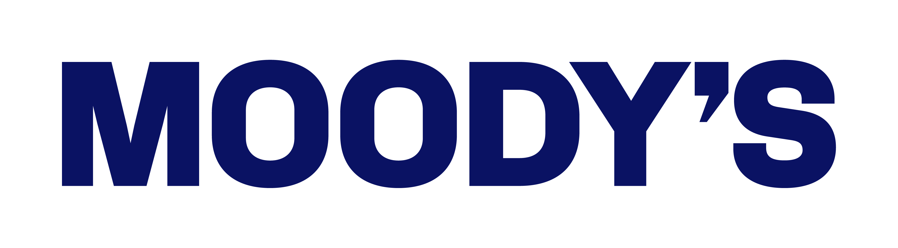

SILVER

